Basket stitch baby blanket

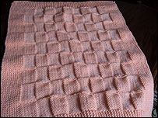

Using 5mm needles and double-knitting wool

Cast on 110 stitches

Knit 20 rows in garter stitch (Knit every row)

Keeping to a border of 10 in garter stitch at each end of knitting

Knit 10, Purl 10 for 10 rows

Next row Purl 10, knit 10 for 10 rows  
(On the first row you will Knit 20 stitches at the beginning and end of row)  
(On the second row you will knit 10 stitches at the beginning and end of row)

Continue in this manner until 14 pattern repeats have been done

Knit 20 rows in garter stitch and cast off loosely

Using the same method you can knit this blanket in any size or any ply of wool.